REPORT for Experiment 11
Experiment Title：
Plaque assay of bacteriophages
Instructor(s)：
Pinmei Wang
Lab Location：
海工楼
Date Performed：
2024.11.17
- Introduction
There are three types of viruses: plant viruses, animal viruses and bacteriophages. Among them, bacteriophages are the main research objects of our experiments.Bacteriophages are found wherever any bacteria are present, and T4 is a virus that infects E. coli.
The drop-on-plate is used to determine the titre of a phage preparation.Add phages to agar medium which has host cells.The following day plates are observed for the presence of plaques in the bacterial lawn that develops.
Plaque are produce because the virus dose not infect all of the host cells.Uninfected one will grow into an opaque layer of cells covering the agar plate.After lysis,cell no longer scatter light and therefore no longer look opaque.
Phage titre is given as plaque forming units/mL,as there may be phage particles present that did not give rise to a plaque.
2. Experimental Purpose
(1).Understand the principle of the phage plaque assay
(2).Be able to calculate the titer of a phage stock
3. Equipment and Materials
(1).Ec T4 NA and Pre
(2).Buffer
(3).1.5mLsterile tube
(4)Pipettes and tips
4. Experimental Procedure
(1) Label each plate (×6) with Group number and time
(2)Making double-layer NA plate (×6)
Pour about 3 mL overlay agar for each NA plate quickly, as agar will start to solidify at room temperature.
- Serial dilution of T4 using Buffer. Pipetting up and down to mix completely.
- Add 10 μL drops of phage onto labelled double-layer plate (duplicate for each dilution).Set at the plates in the hood for 5 min without air flow and moving.

5. Record and Results
WORKSHEET 11
 | Phage dilution
 | 0 | 5 | 25
Plaques in Replicate #1 | / | / | /
Plaque in Replicate #2 | / | / | /
Average plaque number | / | / | /
The titre of the phage stock  (pfu/mL) | / | / | /
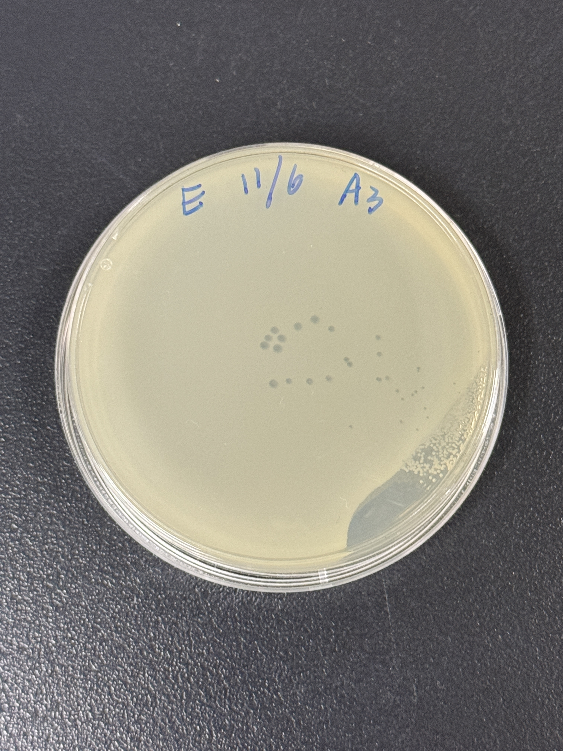
Unfortunately, all the samples were too dense to count, so we ended up borrowing other sets of samples we get 35 plague totally

6. Discussion
Were the plaques clear or turbid? What does this suggest about the type of phage that T4 belongs to (virulent phage or temperate phage)? Explain your answer.
The plaques are clear,which means T4 belong to virulent phage.
Because when the phage completely lyses the infected bacterial cell, a clear plaque is formed.This plaque is often an indication that the phage has a strong lytic ability, capable of rapidly killing host cells and releasing new phage particles.

